**Анкета к 40-летнему юбилею г. Лесосибирска**

**I. Выберите один правильный ответ из трёх предложенных.**

1. Lesosibirsk is situated on the river

1. Angara
2. Volga
3. Yenisei

2. The Cathedral of the Elevation of the Holy Cross is

1. a church
2. a fortress
3. a museum

3. The first Russian settlers put down roots on the Maklakovka River in

1. 1640
2. 1796
3. 1904

4. The longest street in Lesosibirsk is

1. Belinski
2. Gorki
3. Pobeda

5. The Cathedral of the Elevation of the Holy Cross was built in

1. 2007
2. 1995
3. 2002

6. Maklakov Lug was

1. a town
2. a village
3. a river

**II.** **Ответьте на вопросы:**

7. How many people lived in Maklakovo in 1915?

8. When was town Lesosibirsk founded?

9. What is the most famous place where people in Lesosibirsk watch films?

10. What does Ionessi mean?

**III.** **Организуйте следующие слова в предложения:**

11. town, home, is, the, 70000, to, now, people, almost.

12. in, the, Lesosibirsk, Lesosibirsk LDK-1, biggest, is, plant.

**IV. True or False.**

13. The Soviet power was established in Maklakovo in March 1921.

14. The company Lesosibirsk LDK-1 is well – known in the world.

15. More people live in Strelka than in Lesosibirsk.

16. More than 500 Maklakovo men took part in the Great Patriotic War.

VI. Famous people

Who are these people?

17.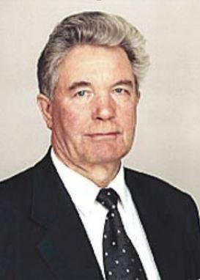 18. 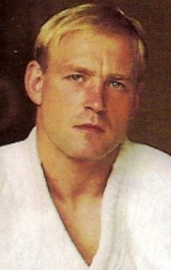 19.

20. Name 10 adjectives about Lesosibirsk.

21. Name 5 sights in Lesosibirsk.